Investigations and Fraud Management
Investigations and Fraud Management
State Capitol Complex
Building 6, Room 817-B
Phone: (304) 558-1970
Fax: (304) 558-2363

The Investigations and Fraud Management Unit (IFM) has the responsibility for conducting general investigations of suspected recipient misrepresentation primarily in the Department’s Income Maintenance and Social Services Programs.

IFM also has the responsibility for pursuing Supplemental Nutrition Assistance Program (formerly known as Food Stamps), and cash assistance repayments.

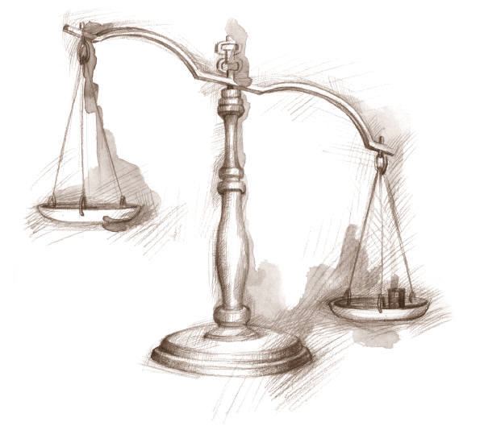
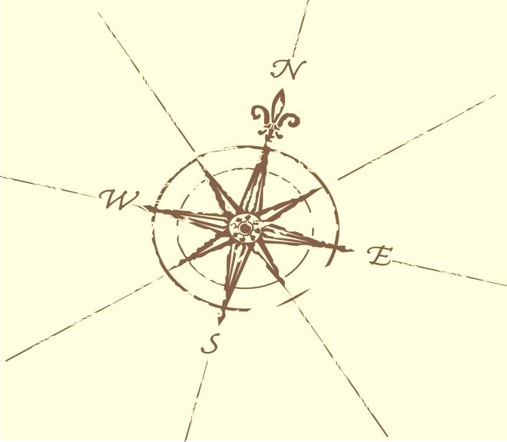

Internal Affairs
Upon request and with the approval of the Inspector General, the Investigations and Fraud Management Unit conducts intra-agency investigations involving allegations of inappropriate employee activity, which might result in administrative (disciplinary) action or referral for criminal prosecution. All such investigations are of a highly-sensitive nature. Every effort is made to maintain confidentiality and to protect the individual privacy rights of all potential investigative witnesses or suspects.

Criminal Investigations
The Criminal Investigations sub-unit investigates allegations of suspected welfare fraud or other criminal activity involving recipients of DHHR benefits or services. Other special investigations may include complaints involving (non-Medicaid) providers, vendors or grantees who receive program-related benefits or financial payments for services from DHHR. Findings are compiled in detailed written investigative reports which are delivered to county prosecuting attorneys to evaluate for further action.

Front-End Fraud
The Front-End Fraud sub-unit performs a more thorough, pre-certification review of applicant/recipient eligibility on cases meeting a certain criteria. The sub-unit is currently operative in seven (7) West Virginia counties. This effort is supported by federal agencies providing related, matching program funds as a highly-effective means of preventing recipient abuse or fraud before it occurs.

Claims and Collections
The Claims and Collections sub-unit is responsible for determining certain recipient benefit overpayment claims; negotiating appropriate repayment agreements; imposing any applicable program sanctions for violators; collecting the overpaid benefits amounts; and, the ongoing monitoring as to the status of DHHR debtor-claims.

Did you know…

Criminal Investigations
The Criminal Investigations sub-unit received 293 referrals in FY 2010-2011. Ninety-three (93) cases worth $531,635 were presented to the prosecuting attorney. Eighty-seven (87) cases worth $529,038 were presented to the grand jury. One hundred nineteen (119) intentional program violations were established.

Front-End Fraud
The Front-End Fraud sub-unit received 1,907 referrals in FY 2010-2011. The actual savings to DHHR was $166,128 with a projected savings of $996,768.

Claims and Collections
The Claims and Collections sub-unit established 5,260 claims worth $4,609,019 in FY 2010-2011. They received collections in the amount of $2,927,950. One hundred thirteen (113) intentional program violations were established.

